November 14, 2012

CAP 103

Computer Graphics History

Plan of Instruction

Effective Date: Fall 2012 Version Number: 2012-1

COURSE DESCRIPTION:
This course introduces students to Computer Graphic Imagery from an historical and cultural angle. Topics include learning about the 2D and 3D tools evolution, the key players in the industry and major landmark productions. Upon completion, the student should have acquired an extensive vocabulary of the CGI field and have a global view of this industry.

CONTACT/CREDIT HOURS

Theory Credit Hours 3 hour
Lab Credit Hours 0 hours
Total Credit Hours 3 hours

NOTE: Theory credit hours are a 1:1 contact to credit ratio. Colleges may schedule lab hours as manipulative (3:1 contact to credit hour ratio) or experimental (2:1 contact to credit hour ratio).

PREREQUISITE COURSES

As determined by college.

CO-REQUISITE COURSES

As determined by college.

PROFESSIONAL COMPETENCIES
- Describe the key events, people and technologies linked to CGI.
- Discuss the extraordinary events that shaped the CGI landscape.

INSTRUCTIONAL GOALS

- Cognitive – Comprehend CGI timeline and technology evolution.

- Psychomotor – Can discern roughly the age of a production or visual effect.

- Affective – Value the importance of knowing past events to better understand the fast evolving nature of this field.

STUDENT OBJECTIVES

Condition Statement: Unless otherwise indicated, evaluation of student’s attainment of objectives is based on knowledge gained from this course. Specifications may be in the form of, but not limited to, cognitive skills diagnostic instruments, manufacturer’s specifications, technical orders, regulations, national and state codes, certification agencies, locally developed lab/clinical assignments, or any combination of specifications.

STUDENT LEARNING OUTCOMES

MODULE A – COMPUTER GRAPHICS MILESTONES
MODULE DESCRIPTION – This module instructs students on key milestones and breakthrough discoveries in the CGI field. Topics include pioneers of CGI, breakthrough movies, notable organizations, computer science research, and the movement from analog to digital.
PROFESSIONAL COMPETENCIES | PERFORMANCE OBJECTIVES | KSA
A1.0 Describe the key events, people and technologies linked to CGI. | A1.1 This competency is measured cognitively. | 2
LEARNING OBJECTIVES |  | KSA
A1.1.1 Identify CGI pioneers in their relative field.  A1.1.2 Identify geographical context of CGI.  A1.1.3 Describe CGI common vocabulary.  A1.1.4 Identify movie breakthrough timeline.  A1.1.5 Describe institutes and production companies.  A1.1.6 Identify Computer Science role.  A1.1.7 Describe transition from analog tools to digital.  A1.1.8 Explore famous case study. |  | 2  2  3  2  3  1  2  3
MODULE A OUTLINE:
Computer Graphic Milestones
- Pioneers of Computer Graphic Imagery
- Breakthrough movies
- Notable organizations
- Computer Science research
- From analog to digital

MODULE B – CASE STUDY
MODULE DESCRIPTION – This module instructs students on recent and upcoming movies and the companies responsible for the VFX industries in the U.S. and the world.
PROFESSIONAL COMPETENCIES | PERFORMANCE OBJECTIVES | KSA
B1.0 Discuss the extraordinary events that shaped the CGI landscape. | B1.1 This competency is measured cognitively. | 2
LEARNING OBJECTIVES |  | KSA
B1.1.1 Describe the first use of CGI in a movie.  B1.1.2 Describe the context of the introduction of the first CGI animated character in a movie.  B1.1.3 Explain the importance of the visual effects in the movie Abyss.  B1.1.4 Describe how Jurassic Park was the turning point of stop motion effects.  B1.1.5 Explain the impact of Terminator 2 on movie production.  B1.1.6 Describe the impact of full length 3D movies as Toy Story on 2D animation field.  B1.1.7 Explain the renaissance of stereo movie with the case of Avatar. |  | 2  1  2  2  3  2  3
MODULE B OUTLINE:
Case study
- 2001 Space Odyssey
- Young Sherlock Holmes
- The Abyss
- Jurassic Park
- The Terminator 2
- Pixar Movies
- Avatar

LEARNING OUTCOMES Table of specifications
The table below identifies the percentage of learning objectives for each module. Instructors should develop sufficient numbers of test items at the appropriate level of evaluation.

 | Limited Knowledge and Proficiency | Moderate Knowledge and Proficiency | Advanced Knowledge and Proficiency | Superior Knowledge and Proficiency
 | 1 | 2 | 3 | 4
Module A | 12% | 50% | 38%
Module B | 14% | 57% | 29%

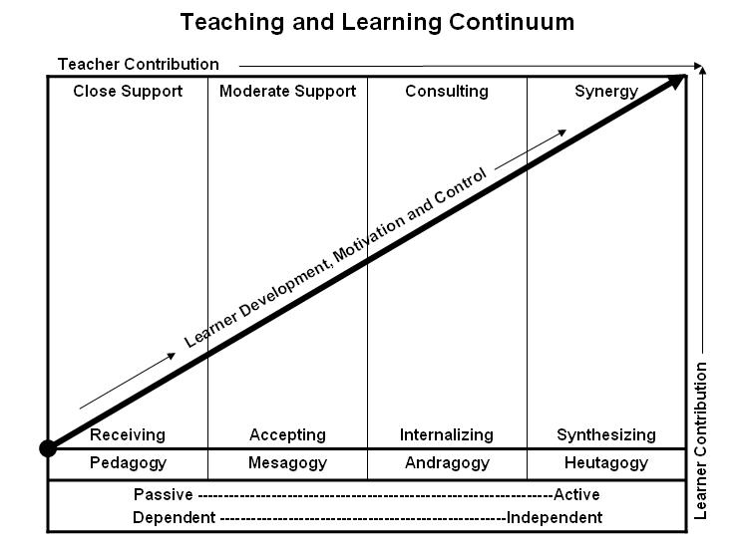

Learner’s Knowledge, Skills and Abilities
Indicator | Key Terms | Description
1 | Limited Knowledge and Proficiency | - Recognize basic information about the subject including terms and nomenclature.  - Students must demonstrate ability to recall information such as facts, terminology or rules related to information previously taught.  - Performs simple parts of the competency. Student requires close supervision when performing the competency.
2 | Moderate Knowledge and Proficiency | - Distinguish relationships between general principles and facts. Adopts prescribed methodologies and concepts.  - Students must demonstrate understanding of multiple facts and principles and their relationships, and differentiate between elements of information. Students state ideal sequence for performing task.  - Performs most parts of the competency with instructor assistance as appropriate.
3 | Advanced Knowledge and Proficiency | - Examines conditions, findings, or other relevant data to select an appropriate response.  - The ability to determine why and when a particular response is appropriate and predict anticipated outcomes.  - Students demonstrate their ability to seek additional information and incorporate new findings into the conclusion and justify their answers.  - Performs all parts of the competency without instructor assistance.
4 | Superior Knowledge and Proficiency | - Assessing conditions, findings, data, and relevant theory to formulate appropriate responses and develop procedures for situation resolution. Involves higher levels of cognitive reasoning.  - Requires students to formulate connections between relevant ideas and observations.  - Students apply judgments to the value of alternatives and select the most appropriate response.  - Can instruct others how to do the competency.  - Performs competency quickly and accurately.
A | Affective Objective | - Describes learning objectives that emphasize a feeling tone, an emotion, or a degree of acceptance or rejection.  - Objectives vary from simple attention to selected phenomena to complex but internally consistent qualities of character and conscience.  - Expressed as interests, attitudes, appreciations, values, and emotional sets or biases.

